2nd Grade Weekly Word Work
Rainbow Writing – write each word in three different colors  Example: teacher teacher teacher | Use Wordle.com to create a wordle of all of your spelling words.  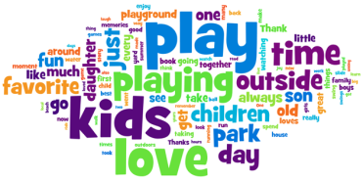 | Write a story, rap, poem, or song, using 5 or more spelling words. Each story should include a beginning, middle, and end.
Have a family member give you a practice test. Your family member should sign their name below the test. Remember to check your answers! | Write 5 complete sentences using proper grammar. Each sentence should have 1-2 spelling words. | Create your own homework – must include using at least 5 or more of your spelling words.
Make a collage with all of your spelling words. Use old magazines or newspapers to find your words or cut out letters to make your words.  Example: | Write each of your word study words in triangle format  Example:  T  Te  Tea  Teac  Teach  Teache  teacher | Type your word study words on the computer in 2 different fonts  Example:  Teacher  Teacher
Students can choose three activities to complete their tic-tac-toe board. If they would like, they can go right to left, top to bottom, or diagonally. However, it may be ANY three activities. Please place an X over the activities you complete and turn in this form and those activities on Friday. Activities should be completed in the spelling notebook.

